**STRUCTURAL MRI RADIOMIC ANALYSIS**

**FOR DIFFERENTIAL DIAGNOSIS OF RADIATION INJURY AND TRUE PROGRESSION AFTER STEREOTACTIC RADIOTHERAPY OF BRAIN METASTASES**

**Project introduction including relevance and topical issues**

***Brain metastases***

Management of patients with brain metastases (BM) is currently of high importance with the continual increase of BM incidence and prevalence as well as with a wider portfolio of treatment possibilities. Radiotherapy (RT) is the cornerstone in the treatment of BM and almost all patients with BM sometimes undergo radiation during their illness. The increasing incidence of BM is a paradoxical consequence of the general success of modern systemic treatment of disseminated cancer in terms of prolonged survival. Nevertheless, we are currently witnessing a paradigm shift with an emphasis on the quality of life of irradiated patients rather than survival [1]. New primary objectives of prospective randomized trials evaluating different RT techniques are quality of life and cognitive function [2].

Nevertheless, local control is still of paramount importance in respect to the indication of further systemic treatment including immunotherapy for intracranial as well as an extracranial disease [3]. From the perspective of health care payers is the intracranial local control, objectified on follow-up magnetic resonance (MRI), a frequent prerequisite for the indication of mentioned modern systemic therapy. Thus, appropriate evaluation of follow-up MRI is of high importance.

***Radiotherapy and treatment-related changes***

Many RT techniques are currently available for personalized palliative treatment of patients with brain metastases ranging from whole brain radiotherapy (WBRT) used for decades to modern targeted stereotactic radiotherapy delivered by linear accelerators. Stereotactic radiotherapy is characterized by a high dose targeted to metastasis (or tumor bed in the case of adjuvant post-operative RT) delivered in generally less than five fractions and with a steep dose gradient to surrounding healthy brain tissue. It is a challenging RT approach with high demand on precision among to know-how and access to modern technology [5]. Currently, it is standard for patients with limited brain metastases (up to 5 brain metastases is the reasonable attitude, taking into account the summary volume of BM) as well as for patients after metastasectomy based on seminal prospective clinial trials [6-8]. Ongoing trials are evaluating the role of stereotactic RT for multiple BM up to 15 brain metastases [9].

Proper evaluation of follow-up MRI is challenging in patients with primary as well as secondary brain tumors [10]. Special Response Assessment in Neuro-Oncology (RANO) criteria were developed for these patients to overcome limitations of otherwise generally used RECIST criteria [11]. Specifically for evaluation of brain metastases, RANO-BM criteria were developed defining measurable and non-measurable lesions with different criteria needed to call a progression.

A familiar challenge for neuroradiologists and neuro-oncologists is differentiating between radiation treatment effect and disease progression in the central nervous system. Both entities are characterized by an increase in contrast enhancement on MRI and present with similar clinical signs and symptoms that may occur either in close temporal proximity to the treatment or later in the disease course. When radiation-related imaging changes or clinical deterioration are mistaken for disease progression, patients may be subject to unnecessary surgery and/or a change from otherwise effective therapy. Similarly, when disease progression is mistaken for treatment effect, a potentially ineffective therapy may be continued in the face of progressive disease [12]. With median time to event around 7 months, the incidence of adverse radiation effect range between 5-10 % depending on size and volume of irradiated lesion [13].

RANO-BM working group acknowledges the current limitations of valid differentiation between radiation treatment effects and true progression [11]. We quote: “On the basis of a literature review and extensive discussions, we found the literature insufficiently robust to conclude that any one modality or approach can be recommended across all patients to distinguish between radiation necrosis and true progression. Instead, we recommend clinical judgment and involvement of a multidisciplinary team. We recognize this recommendation is less than satisfactory and agree that more sensitive and specific methods to distinguish between treatment effect and tumor progression are needed.“ [11].

***Artificial intelligence and Radiomics***

The practice of medicine is changing with the development of new Artificial Intelligence (AI) methods of machine learning. Coupled with rapid improvements in computer processing, these AI-based systems are already improving the accuracy and efficiency of diagnosis and treatment across various specializations [14].

Nowadays, radiology, as well as radiotherapy, strongly relies on the help of computers, especially when dealing with large 3D image data. Finding important image content that is often hidden to the naked eye is called radiomics, which means extraction of image or object features (descriptors) that quantitatively characterize the image or its parts in mathematical terms. Features can be based on intensities, colors, textures, shapes, locations, etc. For a long time, these features have been designed by the human mind but recently artificial intelligence has started to select them by exploring a very large feature space and selecting those features that are most relevant for the given task. Typically, this is done using machine learning (mostly so-called deep learning) based on training image data that are accompanied by the correct answer (so-called ground truth). Therefore, a retrospective cohort with known ground truth is mostly used for training and selection of radiomic features. Validation can then be performed on a prospective cohort. Some pioneer reports prove this approaches in the evaluation of brain MRI, such as the recent report by Mulford et al performing radiomic analysis of post-operative cavity to predict local control after adjuvant stereotactic radiotherapy. Nevertheless, only pre-RT MRI scan was used without analysis of RT-related information (dosimetry, dose distribution, etc.) [15].

In conclusion, it is reasonably assumed that there will be a significant increase of incidence of patients with BM indicated to stereotactic radiotherapy. Exact and valid evaluation of follow-up MRI after targeted stereotactic radiotherapy represents an **unmet clinical need** which is increasingly important for the individual patient in respect to increasing possibilities of modern systemic treatment of disseminated disease. Moreover, due to the limited availability of advanced MRI or PET/CT methods for brain imaging (non-FDG tracers) for further imaging of equivocal findings on standard contrast enhanced structural MRI, the development of other approaches is recommended.

The aim of presented study is to develop a radiomic model for the evaluation of contrast enhanced structural brain MRI after targeted stereotactic radiotherapy of brain metastases in terms of differential diagnosis of radiotherapy-related changes and true progression in order to increase sensitivity and specificity of MRI evaluation.

**Preliminary data**

An increasing number of BM patients is irradiated in our institution employing state-of-the-art RT techniques such as stereotactic radiosurgery, fractionated stereotactic radiotherapy, single isocentre multiple target stereotactic radiotherapy and others, mirroring increasing evidence supporting this RT approach not only for patients with small single BM (table 1).

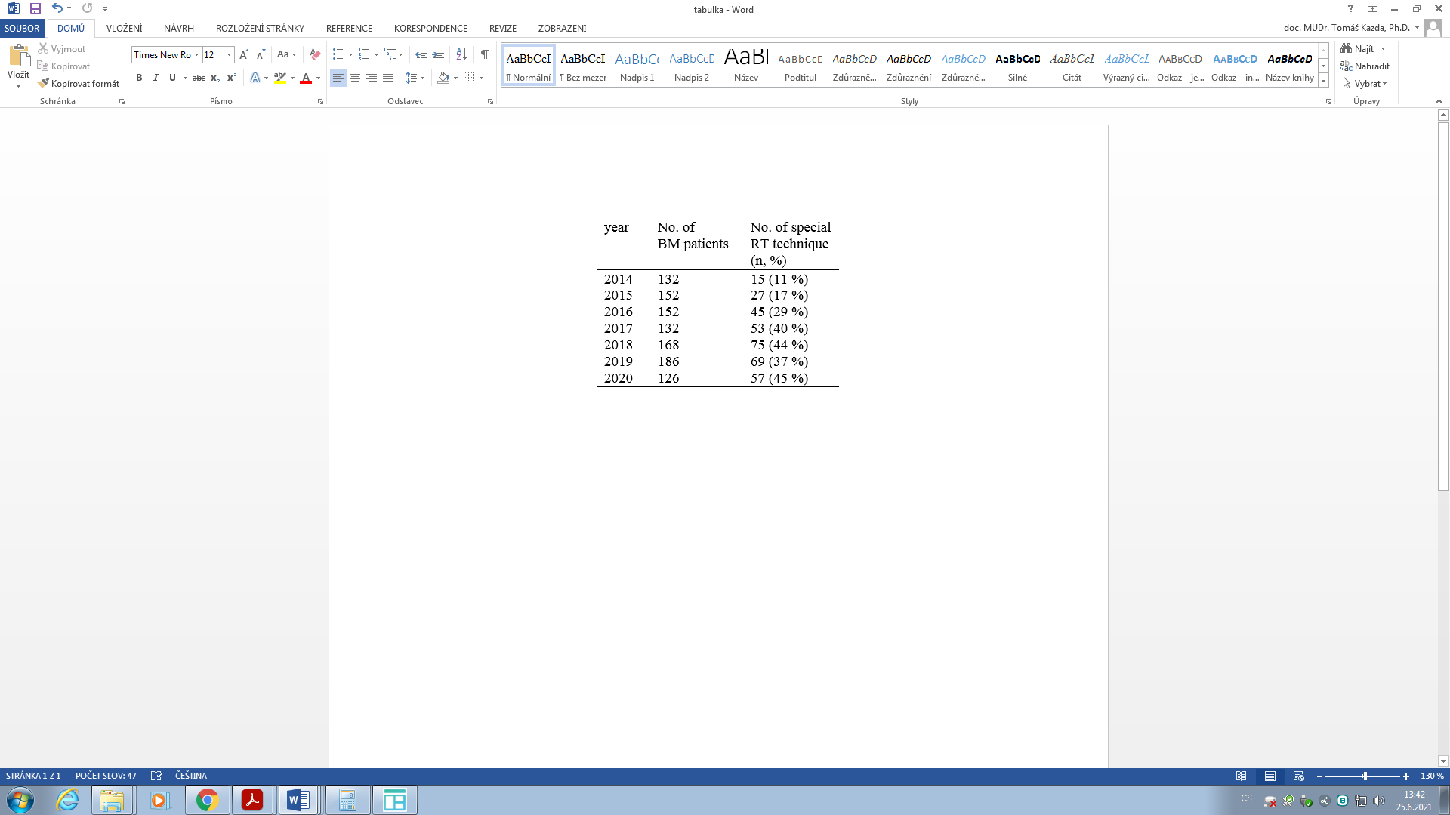Subsequently, more and more patients are discussed within our institutional multidisciplinary brain tumor board with equivocal findings on follow-up MRI. Accurate diagnosis of RT related changes or true progression is extremely important with respect to interruption or continuation of modern systemic therapy such as targeted therapy or immunotherapy. Figure 1 describes non small cell lung cancer patient with solitary frontal lobe metastasis, which was irradiated by fractionated stereotactic radiotherapy 3x8 Gy (9 Gy to central part of metastasis as a controlled dose gradient) during March 2020. After small regression and stabilization, equivocal increase of

contrast enhancing lesion was described on two

following MRI 3/2021 and 5/2021. No pathological avidity was described on 18FDG PET (6/2021) and the patient may continue with the administration of current targeted therapy. *table 1: number of BM patients*

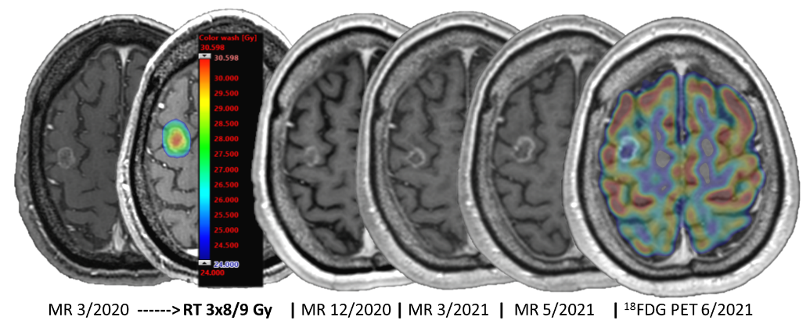

*Figure 1: illustrative case with equivocal evaluation of follow-up MRI*

*after stereotactic RT*

Recently, we have already started to attend to the analysis of structural MRI brain tumor images using deep learning techniques, more specifically so-called convolutional neural networks (CNNs). We have focused on the tumor segmentation task, so our networks can find features important for distinguishing tumor (and also edema) from the rest of the image. In this project, we will adapt our networks so that they focus on features important for the creation of a radiomic model that could cope with the characterization of tumor progression after radiotherapy and distinguishing radiation injury from progression.

**Hypothesis and motivation**

We hypothesize that the radiomic model, utilizing machine learning approaches, for contrast enhanced structural MRI in patients after targeted stereotactic radiotherapy will increase predictive value and validity of the classical evaluation of follow up MRI by a physician.

The topicality of valid follow up MRI in patients after stereotactic radiotherapy of brain metastases is currently highly relevant in relation to the increasing number of available targeted therapy (or immunotherapy) for patients with disseminated disease provided that the disease in brain is controlled.

Our motivation is also to enhance mutual collaboration between researchers in the field of computer science and clinical researchers and physicians.

Presented project proposal has also very convenient cost/benefit ratio with direct clinical impact on health care (applicability). The majority of budget represents personal costs, which is fully in accordance to planned analyses (computer science; radiotherapy).

**Aims of the project**

Aim 1: To create retrospective cohort of at least 100 patients irradiated by targeted stereotactic

radiotherapy with available clinical and detailed radiotherapy data as well as follow-up MRI

(Training cohort with defined ground truth for Aim3)

Aim 2: To prepare radiomic structure tailored for analysis of metastases on contrast enhanced

structural brain MRI.

Aim 3: To develop a radiomic model for the evaluation of contrast enhanced structural brain MRI

after targeted stereotactic radiotherapy of brain metastases in terms of differential diagnosis of

radiotherapy-related changes and true progression.

Aim 4: To create prospective cohort of patients irradiated by targeted stereotactic radiotherapy and

with regular standardized follow-up (Validation cohort for Aim 5).

Aim 5: To validate developed radiomic model (Aim 3) employing prospective patients from Aim 4.

Aim 6: To describe clinical course in patients with discordant MRI evaluation according to the

radiologist and according to the radiomic model.

**Methods and approaches**

*Retrospective cohort:* All patients indicated to upfront of post-operative radiotherapy for brain metastases at MMCI between 2016-2021 will be screened for eligibility. Inclusion criteria include: 1) completion of prescribed targeted stereotactic radiotherapy, 2) available pre-radiotherapy brain MRI as well as follow-up MRI for exact definition of RT-related changes (tumor regression, pseudoprogression, radionecrosis) vs. tumor progression, 3) available clinical (including tumor histology or history of corticosteroids administration) as well as RT treatment plan data. Exclusion criteria include: 1) signed disagreement with the use of personal medical data for research purposes in pseudonymized or anonymized form, 2) reirradiation to the same brain lesion.

Clinical and MRI data will be used to clear definition of ground truth by experienced neuroradiologist and radiation oncologist reflecting post-MRI clinical course of disease and reflecting insufficiency in RANO-BM criteria for evaluation of lesions after stereotactic radiotherapy, as discussed in the introductory section.

Cohort of at least 100 retrospective patients will be created and their clinical, radiotherapy as well as MRI data will be transfered in pseudonymized form to the workplace of the main co-investigator for subsequent radiomic analyses (training phase).

*Prospective cohort:* All patients indicated to upfront of post-operative radiotherapy for brain metastases at MMCI will be screened for eligibility. Inclusion criteria include: 1) completion of prescribed targeted stereotactic radiotherapy prepared based on planning contrast enhanced MRI performed no later than 2 weeks before initiation of RT, 2) available pre-operative brain MRI in patients indicated to adjuvant stereotactic RT to tumor bed, 3) patients aged over 18 years, good performance status (Karnofsky index ≥ 70), 4) favorable survival prognosis of more than 3.8 months as predicted by the graded prognostic assessment score [27]. Exclusion criteria include: 1) prior RT to pertinent metastasis, 2) contraindication to MRI including severe claustrophobia, 3) contraindication to targeted stereotactic RT including multiple brain lesions or leptomeningeal disease, 4) pregnancy or breastfeeding (women of childbearing potential must practice adequate contraception and must have negative pregnancy test ≤ 2 weeks prior study registration), 5) any other factors that, in the opinion of the site investigators, would interfere with adherence to study requirements, 6) inability or unwillingness of subject to sign written informed consent.

After consultations with eligible patients and answering all questions, informed consent approved by the Institutional Review Board will be signed by each patient and investigator before study enrollment.

Cohort of at least 50 prospective patients and cohort of at least 100 retrospective patients will be created and their clinical, radiotherapy as well as MRI data will be transfered in pseudonymized form to the workplace of the main co-investigator for subsequent radiomic analyses (training phase).

*Radiotherapy procedures:*

Standard of care stereotactic radiotherapywill be performed at the Department of radiation

oncology at MMCI using specialized stereotactic linear accelerator Varian TrueBeam STx, version 2.5 (6 MV FFF - 1400 MU/min, 10 MV FFF - 2400 MU/min; HD120MLC collimator with 60 isocentric 2.5mm leafs; PerfectPitch 6 degrees of freedom couch; VMAT with Jaw tracking; on board cone beam CT). The radiotherapy approach (dose, fractionation, technique) will be fully tailored based on the clinical need without any adjustments based on research purposes.

*Follow-up MRI*

After stereotactic radiotherapy, patients will be regularly followed-up with contrast enhanced brain MRI every 2 months for the first 6 months and then every 3 months. All individual metastatic lesions will be evaluated separately based on modified RANO-BM criteria recommendation for lesions after stereotactic radiotherapy acknowledging that radiographical evidence of enlargement of target and non-target lesions may do not necessarily represent tumour progression [11]. If radiographical evidence of progression exists, but clinical evidence indicates that the radiological changes are due to treatment effect (and not to progression of cancer), additional evidence will be needed to distinguish between true progression and treatment effect: The MRI scan will be repeated within 6 weeks. An investigator can choose a shorter time interval if progressive symptoms or other clinical concerns arise. Continued tumour growth will be consistent with radiographical progression. Stabilisation and shrinkage of a lesion will be consistent with RT treatment effect. For patients with equivocal results even on the next restaging scan, the scan can be repeated again at a subsequent protocol-scheduled assessment or sooner, although surgery or use of an advanced imaging modality (such as perfusion MRI, MR spectroscopy, or 18FDG PET), fully respecting the best clinical practice and patient´s need according to his symptoms respecting the palliative intent of brain metastasis treatment. In this case of continuously progressing neurological status, the equivocal MRI (irradiated lesion evaluation) will be considered as tumor progression.

Presence of a new lesion will not be reported as local progression (from the irradiated lesion point of view) but as a distal brain progression.

*Radiomic analyses:*

In recent years, a clear shift from traditional human-designed and machine-learning methods to deep learning is apparent, in particular towards deep convolutional neural networks (CNNs) [16], which have proven to excel in many computer vision problems. The advantage of deep learning is that the neural networks can automatically learn the appropriate features along with the prediction models. Therefore, we will primarily rely on deep learning but we will combine it with human-designed approaches, which proved to be superior to pure automatic learning in our experience.

Although the use of CNNs (typically based on U-Net like architectures nowadays) for 3D MRI data is challenging because of its enormous memory requirements, the class imbalance problem (caused by the fact that regions with pathological tissues are significantly smaller than are the regions of healthy tissue), and the typical lack of training data, deep learning often leads to excellent results [17]. It has been shown that the key aspects for successful deep learning are data augmentation [18] and appropriate preprocessing techniques [19], so we will also pay attention to these two accompanying tasks for which human-designed approaches can be utilized. In applications where not enough training data is accessible, it is even possible to take a network trained for a different problem and to use so-called transfer learning. For example, non-biomedical GoogLeNet network was used for feature extraction and reached a mean classification accuracy of 98% for classifying glioma, meningioma, and pituitary tumours [20]. Hence, we will also try transfer learning in this project. For feature extraction, we will test pre-trained networks, such as InceptionV3, ResNet, or VGGNet, and select those that will yield the best results. We will also pay attention to the explainability issue and analyse the behaviour of the networks and the genesis and role of individual features. We will also try combining these learning approaches with human-designed radiomic feature detection.

**Statistical consideration:**

As confirmed by an experienced statistician in our team and following other similar projects (radiomic analysis) currently supported by the Czech Health Research Council grant, no rigorous statistical estimation of the required number of patients (power) is necessary given the nature of the proposed project. The number of retrospective patients (100 patients) is usual for the training phase of new radiomic models and corresponds to the number of patients (with at least one follow-up MRI) treated in the Department of radiation oncology MMCI during last 5 years (with increasing number every year). The number of prospective patients (50 patients) is usual for the validation phase of developed radiomic models and reflects the number of patients treated at MMCI during project duration (concerning needed follow-up).

Data will be described using standard summary statistics, i.e., median and interquartile range or mean and standard deviation for continuous variables and frequencies and proportions for categorical variables. The diagnostic value of the newly developed model will be measured using quantification of the performance (sensitivity, specificity, and predictive values).

**Time schedule and milestones of the project, justification of project duration**

The entire project is planned for the period from May 2022 to December 2025, which means 44 months. The subjects´ enrollment for prospective part is planned to start immediately after preparation of all administrative documentation (information materials for patients, printed as well as electronic Care Report Forms in collaboration with statistician, etc.), not later than at the half of 2022. The overall time needed for patients enrollment (prospective part) is 24 months reflecting the patients´ throughput in our department and reflecting time needed for follow up (6 months). It is estimated to finish patients recruitment in the middle of 2024 with at least 50 patients in prospective part. We expect higher recruitment rate than 2 patients /months, however, only patients who will be able to undergo control MRI will be included in the study (estimated 50 patients who will be able to finish the whole follow-up protocol). We expect to include 12 patients during 2022, 25 patients during 2023 and 13 during 2024.

Time schedule for retrospective part is summarized below.

The overall schedule of the project is presented in a Gantt chart in Figure 2 (dark blue is MMCI, cyan is FI-MU)



*Figure 2: Gantt chart of the project*

**Reference**

1. Gondi V, et al.: Control versus cognition: the changing paradigm of adjuvant therapy for resected brain metastasis. Neuro Oncol. 2018;20(1):2-3.
2. Kazda T, et al.: Why and how to spare the hippocampus during brain radiotherapy: the developing role of hippocampal avoidance in cranial radiotherapy. Radiat Oncol 2014; Jun 16;9:139.

Tawbi HA. Combined Nivolumab and Ipilimumab in Melanoma Metastatic to the Brain. N Engl J Med. 2018;379(8):722-730.

1. Suwinski R. Combination of immunotherapy and radiotherapy in the treatment of brain metastases from non-small cell lung cancer. J Thorac Dis 2021;13(5):3315-3322.
2. Fadrus P, Kazda T, et al. Targeted Radiotherapy of the Tumor Cavity after Surgical Resection of Aggressive Recurrent Brain Metastasis: A Case Report. Case Rep Oncol. 2020 ;13(1):233-238.
3. Brown PD, et al. Effect of Radiosurgery Alone vs Radiosurgery With Whole Brain Radiation Therapy on Cognitive Function in Patients With 1 to 3 Brain Metastases: A Randomized Clinical Trial. JAMA. 2016;316(4):401–9.
4. Mahajan A, et al. Post-operative stereotactic radiosurgery versus observation for completely resected brain metastases: A single-centre, randomised, controlled, phase 3 trial. Lancet Oncol. 2017;2045(17):1–9.

Brown PD, et al. Postoperative stereotactic radiosurgery compared with whole brain radiotherapy for resected metastatic brain disease (NCCTG N107C/CEC·3): a multicentre, randomised, controlled, phase 3 trial. Lancet Oncol. 2017;18(8):1049–60.

1. Li J, et al. Stereotactic radiosurgerz versus whole-brain radiation therapy for patients with 4-15 brain metastases: a phase III randomized controlled trial. Int J Radiat Oncol Biol Phys. 2020;108(3):S21-22.
2. Galldiks N, et al. Imaging challenges of immunotherapy and targeted therapy in patients with brain metastases: response, progression, and pseudoprogression. Neuro Oncol 2020;22(1):17-30.
3. Lin NU, et al. Response assessment criteria for brain metastases: proposal from the RANO group. Lancet Oncol 2015;16(6):e270-8.
4. Walker AJ, et al. Postradiation imaging changes in the CNS: how can we differentiate between treatment effect and disease progression? Future Oncol 2014;10(7):1277-97.
5. Sneed PK, et al. Adverse radiation effect after stereotactic radiosurgery for brain metastases: incidence, time course, and risk factors. J Neurosurg. 2015;123(2):373-86.
6. Kocher M., et al. Applications of radiomics and machine learning for radiotherapy of malignant brain tumors. Strahlenther Onkol. 2020 Oct;196(10):856-867.
7. Mulford K, et al. A radiomics-based model for predicting local control of resected brain metastases receiving adjuvant SRS. Radiat Oncol 2021;29:27-32.
8. Bernal J, et al. Deep convolutional neural networks for brain image analysis on magnetic resonance imaging: a review. Artificial Intelligence in Medicine. 2019;95:64–81.
9. Havaei M, et al. Brain Tumor Segmentation with Deep Neural Networks. Medical Image Analysis. 2017;35:18–31.
10. Nalepa J, et al. Data Augmentation for Brain-Tumor Segmentation: A Review. Front Comput Neurosci 2019; 13.
11. Nadeem MW, et al. Brain Tumor Analysis Empowered with Deep Learning: A Review, Taxonomy, and Future Challenges. Brain Sciences. 2020;10(2):118.
12. Deepak S, et al. Brain tumor classification using deep CNN features via transfer learning. Computers in Biology and Medicine. 2019;111:103345.